**Research Topic:** Convolutional autoencoder Model

**Objective:** The purpose of the model is to greatly reduce noise of data (for example an old image) so that the creation of deep learning models will be more efficient.

**Dataset to test on. TensorFlow eurosat Dataset**

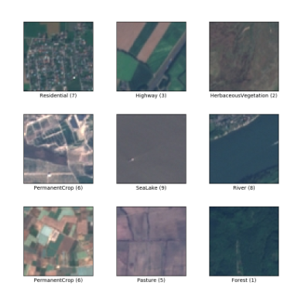

**Datasets:**

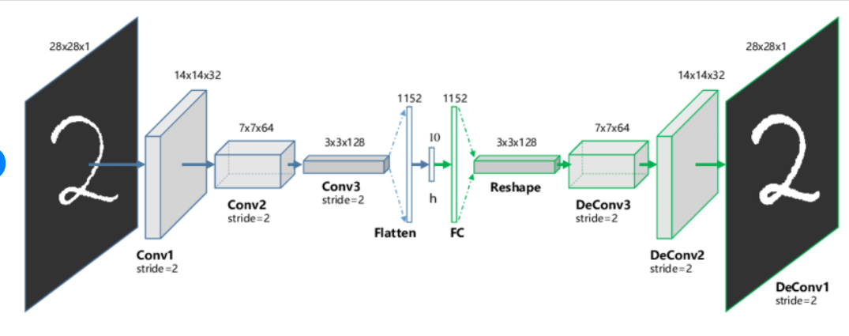

**Sample Image Noise Reduction Situation:**

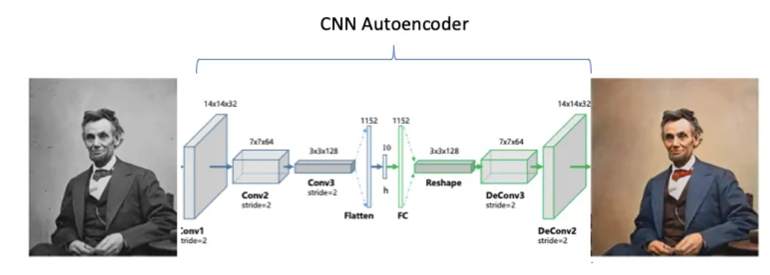

**Datasets which will be used:**

EuroSat Dataset: <https://www.kaggle.com/datasets/apollo2506/eurosat-dataset>

Tensorflow: https://www.tensorflow.org/

**Encoder:**

Encoder will have 3 layers using TensorFlow and Keras.

Relu activation function to be used. The use of RELU aids in preventing the exponential increase in the amount of processing needed to run the neural network.

2 Strides for downsampling the data

**Decoder:**

The decoder will also have 3 layers created using TensorFlow and Keras.

Relu activation function to be used. The use of RELU aids in preventing the exponential increase in the amount of processing needed to run the neural network.

2 strides for upsampling the data